Lab 07 Write-Up

By: Arielle Wood

Part 1:

1. Identify two pixels in Soybean Field A that represent:
2. High Soybean Yield (include images of area of interest and spectral profile)

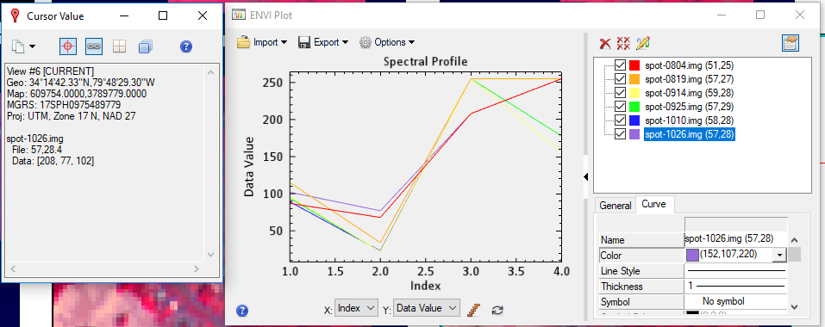

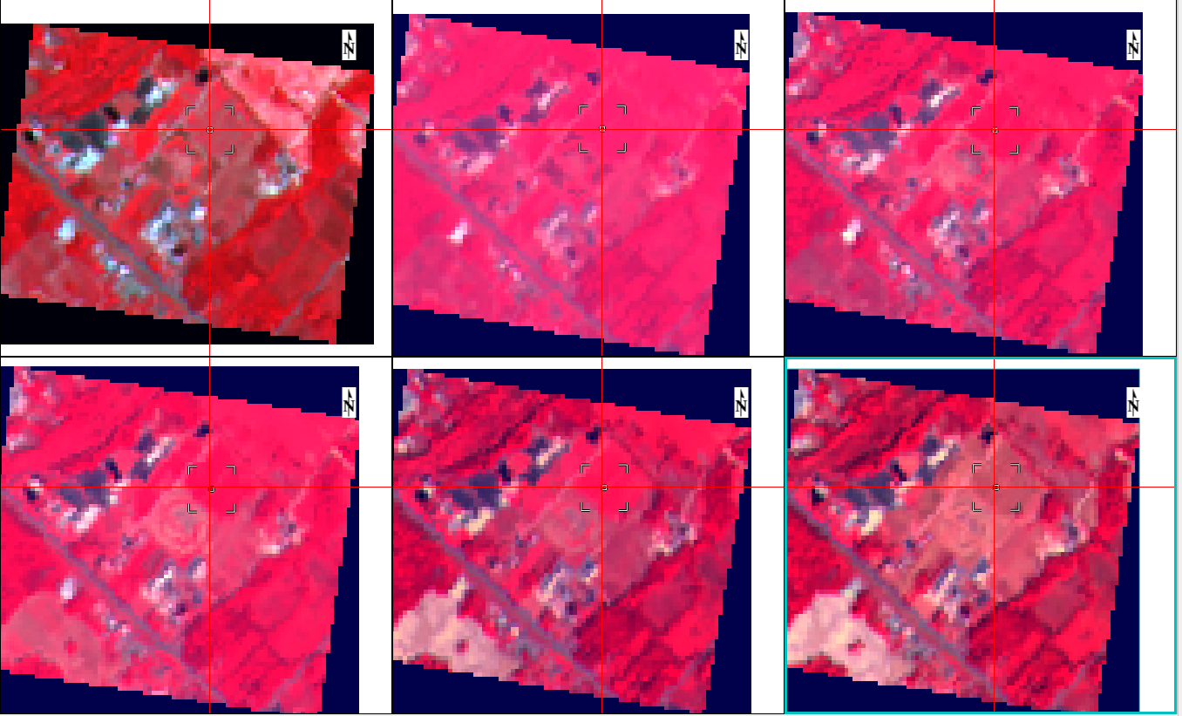

1. Low Soybean Yield (include images of area of interest and spectral profile)

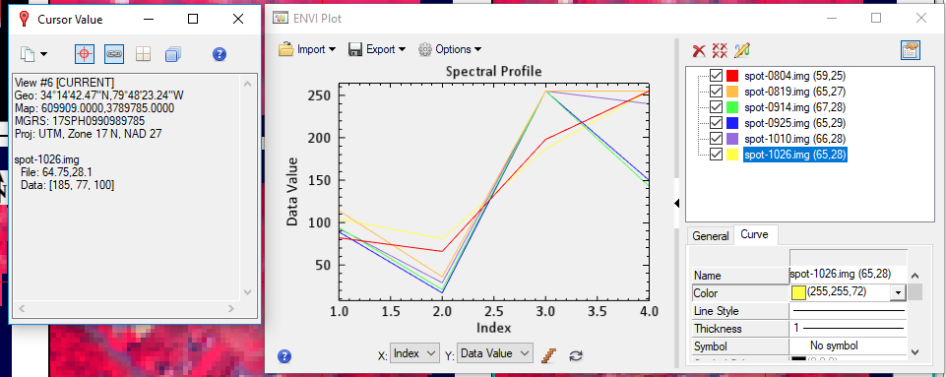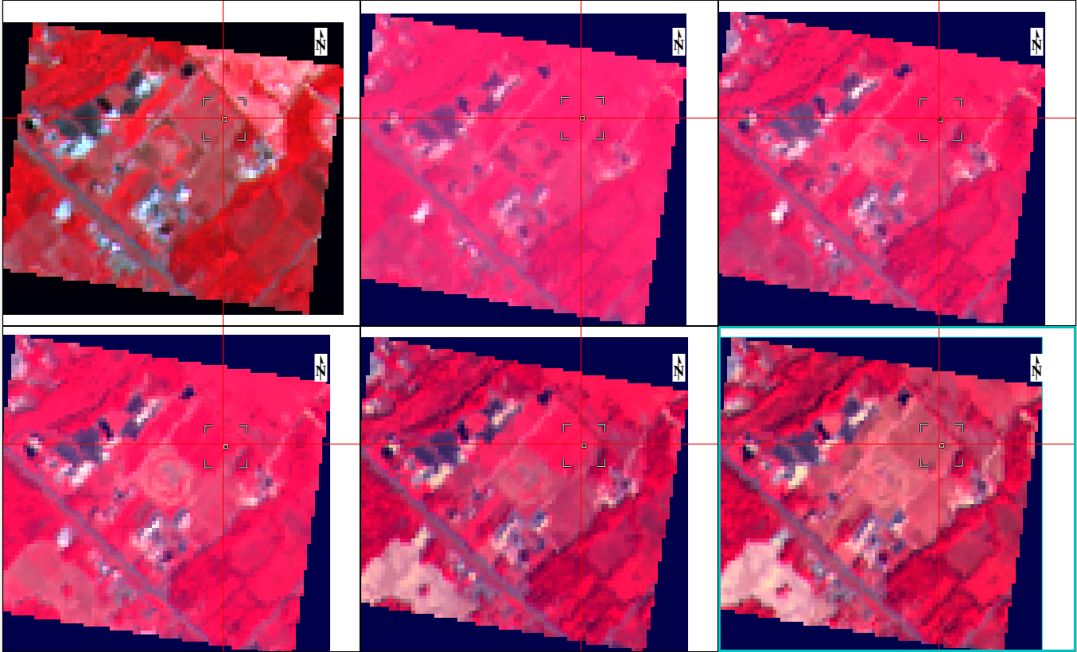

1. Create a simple phenological cycle for soybeans using the dates and the graphs created. Also compute the NDVI for each image. Use the values to show the greening up and senescing down of the plant over time. Compute two other vegetation indices as well.

NDVI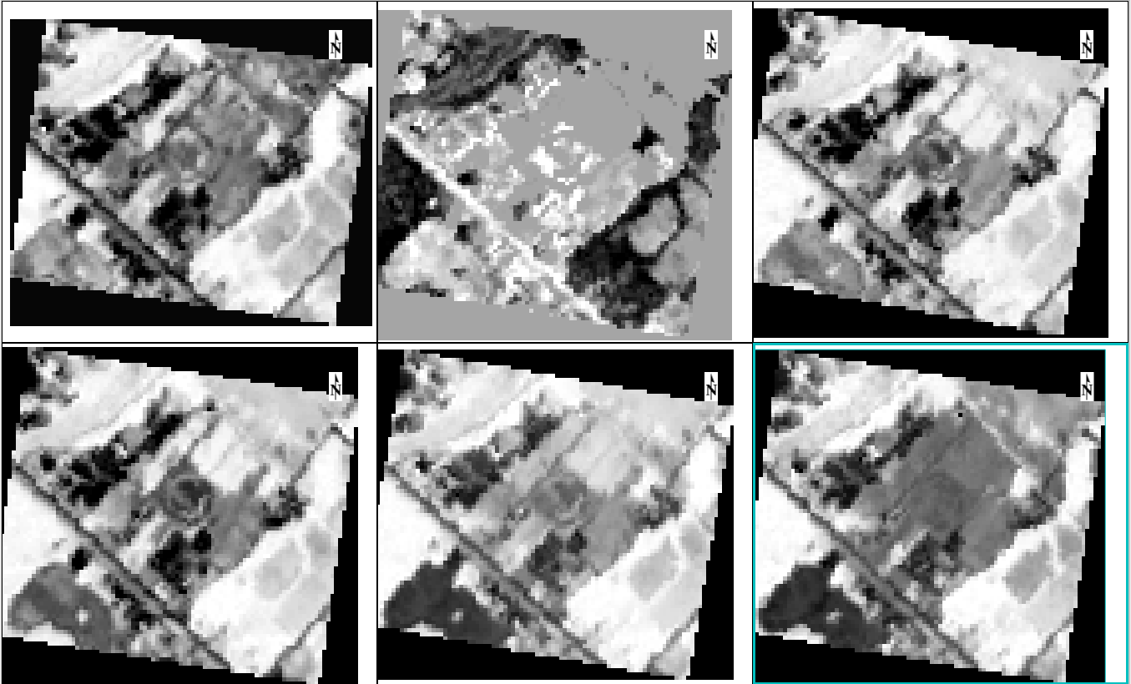

Simple Ratio Index

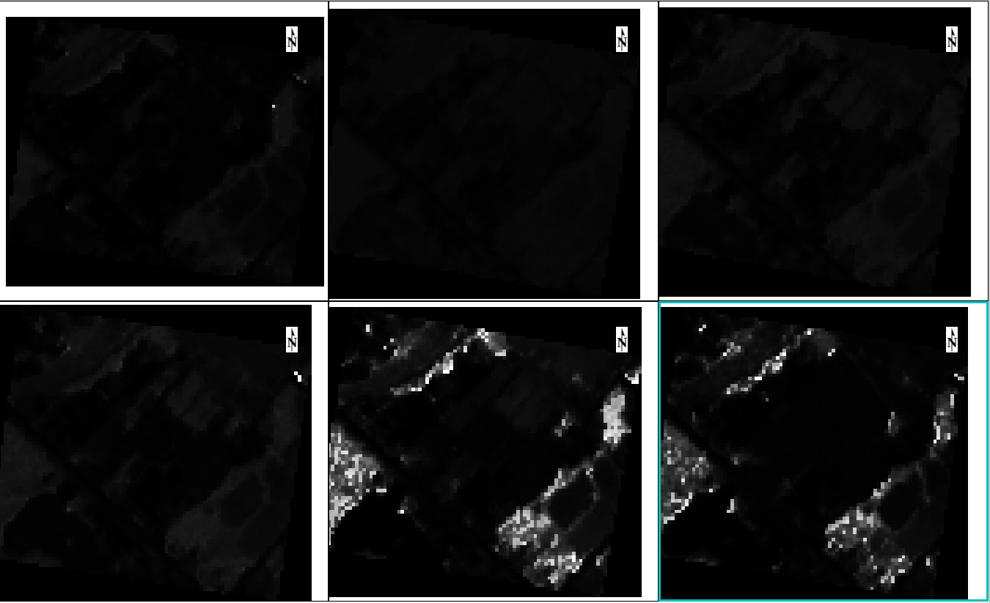

Sum Green Index

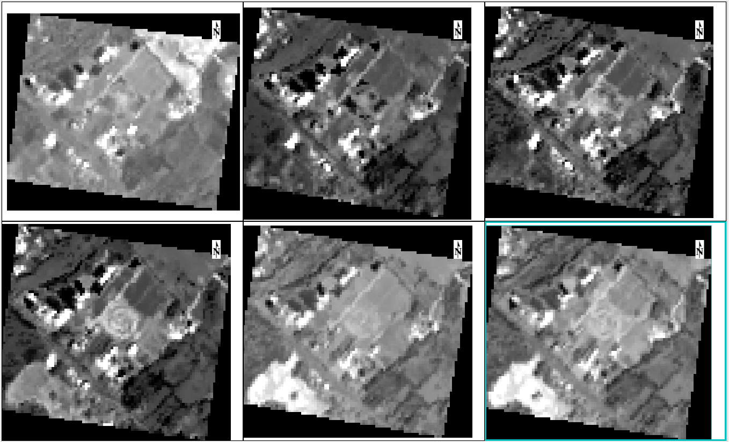

The bright spots in all 3 different calculations represent the areas with the highest amount of chlorophyll, thus the healthiest vegetation. To create a phenological cycle, we use the images, the timeline of the original images, and the brightness of the NDVI calculation. The vegetation is the healthiest in August, and it decreases in health heading towards the winter months. The summer months are the months with the healthiest vegetation.

Part 2:

1. Create a graph using Landsat TM’s seven bands depicting the spectral profile for sugar beets, alfalfa, cotton, and fallow fields. Choose the band that provides the best discrimination between the different land cover types.

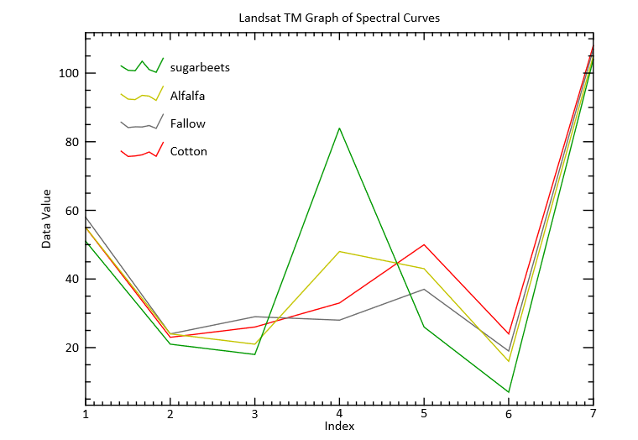

Band 4 is the best band for discriminating all of the different land cover types. This is because it shows the biggest difference between the different land cover types.